SUPPLEMENTARY REGULATIONS
NON SPEED EVENT
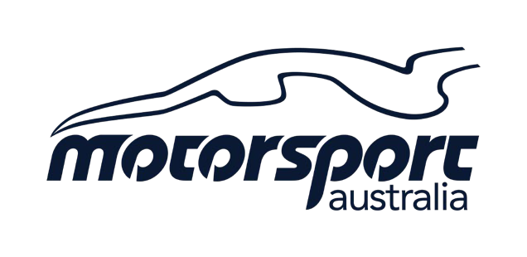

9th and 10th December 2023

NAME OF EVENT: | PAC Junior Come &Try (C&T) and Khanacross Test & Tune (T&T)
TYPE OF EVENT: | Non-Competitive Junior Come & Try and Khanacross Test &Tune  This is a non-competitive event. No times will be recorded or trophies awarded.
VENUE/LOCATION: | PAC 21 Key Lane

The Event is conducted under the FIA International Sporting Code including Appendices, the Khanacross/Motorkhana Standing Regulations, The Motorsport Australia Motor Sport Passenger Ride Activity (MSPRA) Policy the Motorsport Australia Come and Try Policy, these Supplementary Regulations and any Further Supplementary Regulations or Bulletins which may be issued. The Event will be conducted under and in accordance with Motorsport Australia OH&S, Safety 1st, Integrity and Legal, and Risk Management Policies, which can be found on the Motorsport Australia website at www.motorsport.org.au. Certain public, property, professional indemnity and personal accident insurance is provided by Motorsport Australia in relation to the event. Further details can be found in the Motorsport Australia Insurance Handbook, available at www.motorsport.org.au.

EVENT START DATE | 09-12-2023 | PERMIT NUMBER | 323/0912/03
EVENT FINISH DATE | 10-12-2023

ORGANISING CLUB/PROMOTER: | Pakenham Auto Club Inc
ORGANISING COMMITTEE: | Leon Prosser
ADDRESS: | 9 Karri Ct Frankston Nth
EMAIL: | Selica.ta22@gmail.com

CLERK OF COURSE | Leon Prosser | MEMBER ID | 1082457
SECRETARY | Leon Prosser | MEMBER ID | 1082457

ENTRIES OPEN: | On publication | ENTRIES CLOSE: | C&T 8:30am 9/12/2023  T&T 11:30 am 10/12/2034
ENTRY FEES: | $25.00 | MIN & Max ENTRY: | C&T Max 24  T&T Max 40

MINIMUM LICENCE REQUIREMENTS: | Motorsport Australia Introductory License | EVENT START TIME | C&T 8:00am  T&T 11:00am

Entrant Briefing | C&T 09:00am  T&T 11:30 | LOCATION: | Control
SCRUTINEERING TIME: | C&T 8:00am  T&T 11:00am | LOCATION: | Control

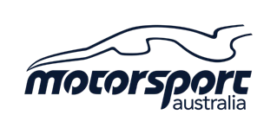
- All vehicles must comply with Schedule A and Group 4H of the Motorsport Australia Manual.
- Fuel must be in accordance with Schedule G of the Motorsport Australia Manual.
- Cars must be adequately muffled.
- Entrants must produce a valid and current:| Motorsport Australia Competition | Licence Club Membership Card of a Motorsport Australia Affiliated Car Club | Log Book (if issued).

- PASSENGERS IN VEHICLES
  - This Event will include a Motor Sport Passenger Ride Activity (MSPRA) which shall be run under and in accordance with the Motorsport Australia MSPRA Policy.

  - This Event will have Instructors in vehicles.

- CLASSES: N/A

- The manner in which the results will be determined and prizes awarded: N/A

- A detailed list of awards offered for each competition: N/A

- Entries will be accepted in order of receipt unless otherwise specified

- The Organisers may refuse any entry in accordance with the NCR.

- Entries from competitors under 18 years of age must be counter signed / consented to by a parent/ guardian.

- The Organiser reserves the right to abandon, postpone or stop the Event in accordance with the NCR.

Integrity, Alcohol, Drugs and Other Substances
Smoking (which includes e-cigarettes and “vaping”) and any naked flame is prohibited within 3 metres of any refuelling/defueling operation.
Motorsport Australia’s National Integrity Framework and any associated policy (including the Australian Anti-Doping Policy. Motorsport Australia’s Illicit Drugs in Sport (Safety Testing) Policy, the Motorsport Australia Alcohol Policy), apply to any activity authorised by Motorsport Australia as published at www.motorsport.org.au.
Any Participant including the holder of a Motorsport Australia Licence (or a Licence issued by another ASN) may be tested for the presence of alcohol, any drug or other banned substance. In addition to any penalty imposed by Motorsport Australia, a further penalty/s may be applied by Sport Integrity Australia.
Consumption of alcohol in any Reserved Area is prohibited until all Competition is concluded each day.

